Software Requirement Specification

NHOM8-SRS-001

Version 1.0

**Revision History**

| Date | Version | Description | Author | Revised by |
| --- | --- | --- | --- | --- |
| 3/12/2018 | 1.0 | First version | Lê Nguyễn Việt Thanh | Lê Nguyễn Việt Thanh |
|  |  |  |  |  |
|  |  |  |  |  |
|  |  |  |  |  |
|  |  |  |  |  |

Table of Contents

**1.** **Introduction** 4

**1.1** **Overview** 4

**1.2** **Scope** 4

**2.** **Functional Requirements** 5

**2.1** **Feature/Component #1: login page** 5

2.1.1 User Interfaces 5

2.1.2 Functional Requirements 6

2.2 **Feature/Component #2:** **Quản lý screens** 7

2.2.1 User Interfaces 7

2.2.2 Functional Requirements 8

**2.3** **Feature/Component #3: Quan Ly Sinh Vien Page** 9

2.3.1 Quan Ly Sinh Vien Screens 9

2.3.2 Functional Requirements 10

**2.4** **Feature/Component #4: Quan Ly Lop page** 11

2.4.1 User Interfaces 11

2.4.2 Functional Requirements 12

# **Introduction**

## **Overview**

This software supports users to view the phone on the online and can order the product.

## **Scope**

Demo version

Demo version is for display purpose only, not link to Database, not link to affiliated sites

Android OS: Android: OS 4.0.X to 6.0.X

Android screen resolutions: 480x800, 720x1280

Support screen orientation in landscape mode only

# **Functional Requirements**

## **Feature/Component #1: login page**

### User Interfaces

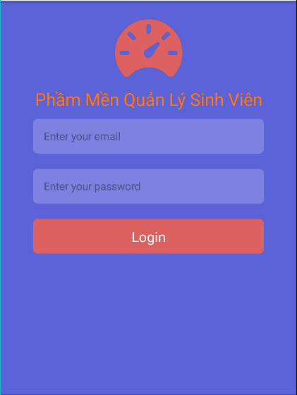

*Image1:* login page

### Functional Requirements

|  |  |  |  |
| --- | --- | --- | --- |
| **Item** | **Description** | **Action** | **Response** |
| login page | Include:   * 1 Button * 2 Text Input * Text * 1 Image | N/A | N/A |
| Button “Login” | Log in successfully if correct account information | Click | Logged in successfully,  Switch to home page |
| Image | Contains the image of the application | N/A | N/A |
| Text Input  “Enter your name ” | Allows the user to enter a login name | N/A | N/A |
| Text Input “Enter your password” | enter password | N/A | N/A |
| Button “Sign up” | For customers who register without an account | Click | Go to the Quản Lý Sinh Viên page, switch to Subscriptions  Page |

## **Feature/Component #2:** **Quản lý screens**

### User Interfaces

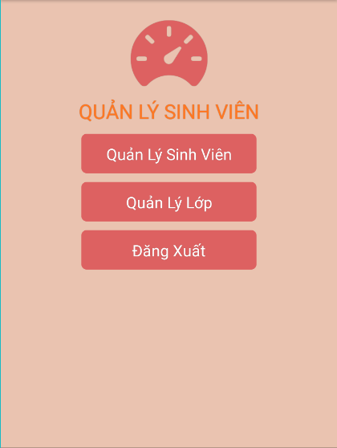

*Image2: Quản lý screens*

### Functional Requirements

|  |  |  |  |
| --- | --- | --- | --- |
| **Name** | **Description** | **Action** | **Response** |
| Registration page | Include:   * 1 Image * 3 Button * Text | N/A | N/A |
| Button “Quản lý sinh viên” | Registration is successful if the correct information is registered | Click | When successful registration will be announced "Successful registration" |
| Button “Quản lý lớp” | If you do not want to continue signing up for an account | Click | Go to the quản lý lớp page |
| Button “Đăng xuất” | If you do not want to continue signing up for an account | Click | Go back to the home page |
| Text “Quản Lý Sinh Viên“ | Name Sign up | N/A | N/A |
| Image | Contains the image of the application | N/A | N/A |

## 

## **Feature/Component #3: Quan Ly Sinh Vien Page**

### Quan Ly Sinh Vien Screens

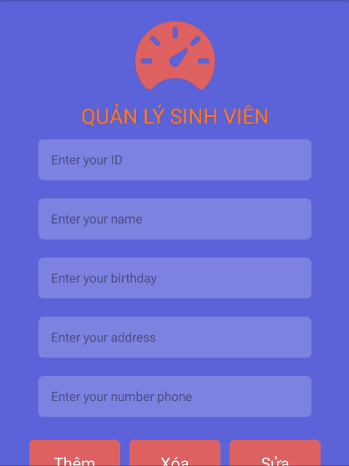

*Image3 : Quản lý sinh viên screens*

### Functional Requirements

|  |  |  |  |
| --- | --- | --- | --- |
| **Name** | **Description** | **Action** | **Response** |
| Home page | Include:   * 1 Image * List view * 5 Text Input * 3 Button | N/A | N/A |
| Image | Contains the image of the application | N/A | N/A |
| Text Input  “Enter your ID ” | Allows the user to enter a ID | N/A | N/A |
| Text Input “Enter your name” | Allows the user to enter a name | N/A | N/A |
| Text Input  “Enter your birthday ” | Allows the user to enter a birthday | N/A | N/A |
| Text Input “Enter your Address” | Allows the user to enter a address | N/A | N/A |
| Text Input  “Enter your number phone ” | Allows the user to enter a number phone | N/A | N/A |

## **Feature/Component #4: Quan Ly Lop page**

### User Interfaces

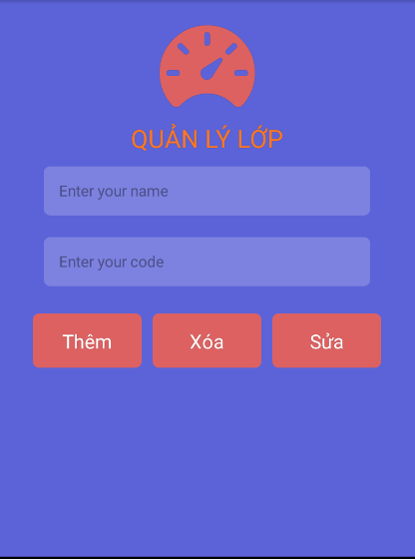

*Image4: Quan ly lop page*

### Functional Requirements

|  |  |  |  |
| --- | --- | --- | --- |
| **Item** | **Description** | **Action** | **Response** |
| login page | Include:   * 3 Button * 2 Text Input * Text * 1 Image | N/A | N/A |
| Button “Thêm” | Thêm in successfully if correct account information | Click | Thêm in successfully |
| Image | Contains the image of the application | N/A | N/A |
| Text Input  “Enter your name ” | Allows the user to enter a login name | N/A | N/A |
| Text Input “Enter your code” | enter code | N/A | N/A |
| Button “Sửa” | For customers who register edit sinhvien | Click | Click |
| Button “Xóa” | For customers who register delete sinhvien | Click | Click |

***---------- End of Document ----------***